**Capstone Project Report**

# Content

# Abstract

## Industry Review - Current practices, Background Research

## Literature Survey - Publications, Application, past and undergoing research

# Data set and Domain

The dataset selected by us is a ‘Global Super Store Dataset’ and we are trying to understand how is the product price varying with sales - Is there any increase in sales with the decrease in price at a day level. The domain for the project is e-commerce supply chain.

* The dataset contains 51290 rows and 24 columns.

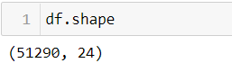

* The features of the dataset are as follows:

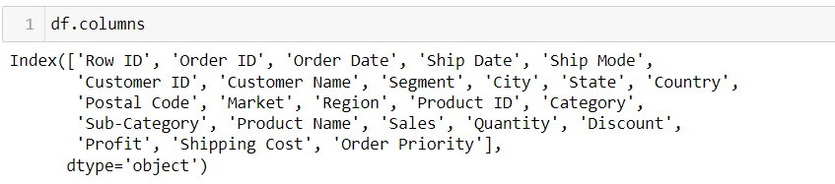

|  |  |  |
| --- | --- | --- |
| S. No | Feature | Description |
| 1 | Row ID | Id of the row |
| 2 | Order ID | Id of the order |
| 3 | Order Date | Date of the order |
| 4 | Ship Date | Date of the shipping |
| 5 | Ship Mode | Mode of the shipping |
| 6 | Customer ID | Id of the customer |
| 7 | Customer Name | Name of the customer |
| 8 | Segment | Type of the customer |
| 9 | City | City the customer belongs to |
| 10 | State | State the customer belongs to |
| 11 | Country | Country of the customer |
| 12 | Postal Code | Postal code of the customer |
| 13 | Market | Market to which the customer belongs |
| 14 | Region | Region of the customer |
| 15 | Product ID | Id of the product |
| 16 | Category | Product category |
| 17 | Sub-Category | Sub-category of the product |
| 18 | Product Name | Name of the product |
| 19 | Sales | Total sales of the product |
| 20 | Quantity | Total quantity sold |
| 21 | Discount | Discount offered on the product |
| 22 | Profit | Total profit generated from the sales |
| 23 | Shipping Cost | Total shipping cost of the product |
| 24 | Order Priority | Priority level of the shipment |

* First 5 rows of the dataset.

